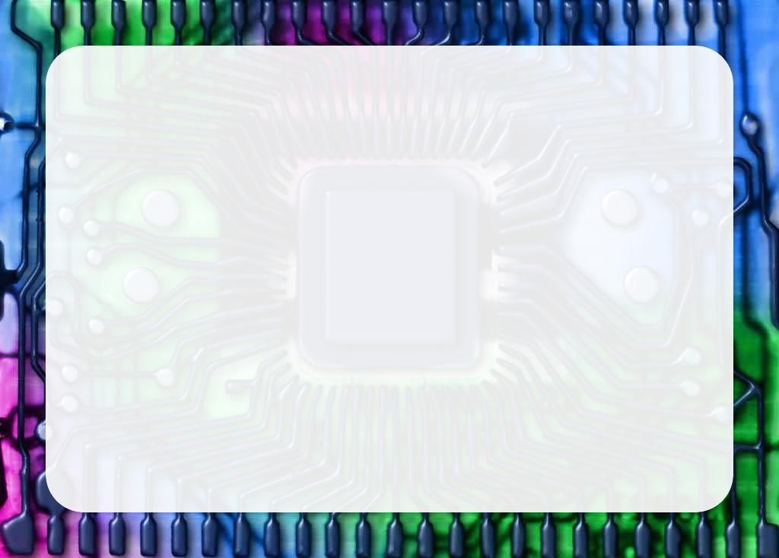

**Learn to Code Class**

Certificate of Participation

This document acknowledges and certifies that:

participated in the ***Learn to Code Class!*** and therefore possesses the skills necessary to create games, animations, and art using the Scratch computer programming language.